Configure SQL Server Express to allow remote TCP/IP connections on port 1433?
Root > Virtual Dedicated Server (VDS) > SQL Server (VDS)
The following article explains how to allow SQL Server Express to accept remote connections over TCP/IP for port 1433. By default, when SQL Server Express is installed it gerates a random port to listen on. In addition, SQL Server Express only listens for connection on localhost. Using the SQL Server Configuration Manager, you will need to tell SQL Server Express to use port 1433.
To allow SQL Server Express to accept remote connections, please follow these steps:
1) Log into your server through Remote Desktop Connection (instructions for connecting to your server through RDC can be found here).
2) Click Start, Programs, Microsoft SQL Server 2005/2008/2012 and select SQL Server Configuration Manager.
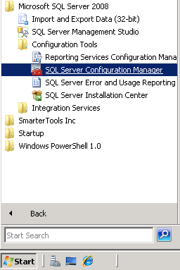
3) Select SQL Server Network Configuration
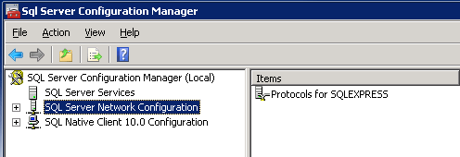
4) Double click on Protocols for SQLEXPRESS
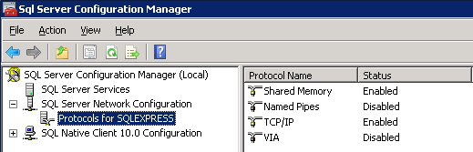
5) Right click TCP/IP and select Properties
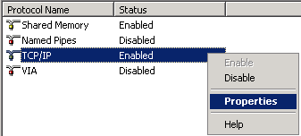
6) Scroll down to IPAll make sure TCP Dynamic Ports is blank and that TCP Port is set to 1433.
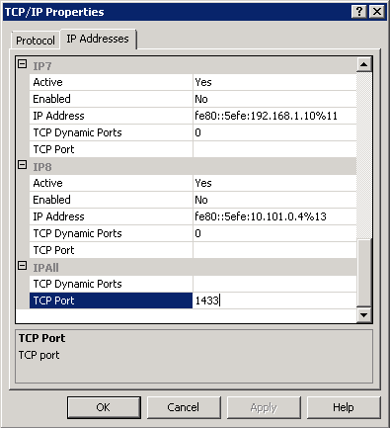
7) Click OK
8) Make sure that port: 1433 is enable on your VDS firewall (instructions for enabling firewall ports can be found here).
9) Mixed mode authentication must also be enabled for remote connections (instructions for enabling firewall ports can be found here).
10) Make sure that the SQL Browser is enabled and running.

